CMPE2600 Lab 13 – Counter Coils

Name: ________________________

We can implement the counting function of trilogi using a counter coil. Trilogi supports up to 128 reverse counters. A counter is also a special kind of relay that has a programmable Set Value (SV). When a counter coil is energized for the first time after a reset, it will load the value of SV-1 into its count register. From there on, every time the counter coil is energized from OFF to ON, the counter decrement its count register value by 1. Note that the coil must go through OFF to ON cycle in order to decrement the counter. If the coil remain energized all the time, the counter will not decrement. Hence counter is suitable for counting the number of cycles an operation has gone through.



When the count register hits zero, all the counter's N.O. contacts will be turned ON. These counter contacts will remain ON regardless of whether the counter's coil is energized or not. So by setting the SV value equal to say 5, we would be able to count 5 events occurring. The SV would count down from 5-4-3-2-1-0.

To turn OFF these contacts, you have to reset the counter using a special counter reset function [RSctr].

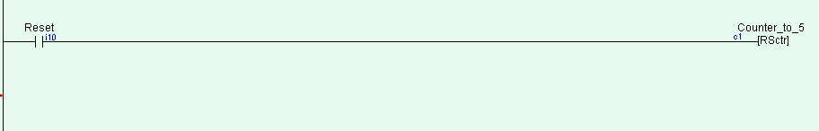

When you click on the tutorial1c8.gif (219 bytes)or tutorial1c9.gif (223 bytes)icon you can create a the reset counter. You can also select the Increment or decrement function for the reverse counter.

The ordinary down-counter (created by clicking on the tutorial1c6.gif (197 bytes)icon) essentially decrements the counter value by 1 from the "Set Value" (SV) and will stop when its count becomes zero. Unlike the ordinary down-counter, a reversible counter is a circular counter which changes the counter present value (PV) between 0 and the SV. When you try to increment the counter past the "Set Value", it will **overflow** to become '0'. Likewise if you try to decrement the counter beyond '0', it will **underflow** to become the "Set Value".

**Part A: Alarm Counter**

When INPUT SENSOR SW9(N.O. mom) has closed 5 times, exactly 600 liters of liquid has gone past it. We want an ALARM to sound(Output1) when exactly 600 liters has gone past it! RESET switch SW10(N.O. mom) will reset the timers and/or counters.

When INPUT SENSOR (N.O. mom) has closed 5 times, exactly 600 liters of liquid has gone past it. We want an ALARM to sound when exactly 600 liters has gone past it! RESET switch (N.O. mom) will reset the timers and/or counters.

Demonstrate your working program on a PLC to your instructor for a check-off.

Instructors Initials: ________________________

**Part B: Bottle Counting System**

An assembly line of beer bottles is to be counted for inventory purposes before being loaded into boxes. The bottles pass a bottle COUNTER1 SW9(N.O. proximity switch; pulses closed when bottle passes) at station A. Every once in a while a bottle is cracked or missing its cap. Of course we do not want the defective ones to be packaged or counted. An operator on the assembly line stands at station B and hand picks out the defective bottles as they pass him. The operator sends the defective bottles down another garbage conveyer which also has a COUNTER2 SW10 (N.O. proximity switch) at station C. The remaining good bottles get loaded.

The important thing to remember is that all the bottles are counted before the defective ones are separated. At the end of the day the boss will look at the ACCUMULATED value of the counter to see how many good bottles have been loaded. This value will be recorded and the operator will reset the counter with a RESET SW11 push-button (N.O. mom).

You will need to have the counter preset to a large SV value of say 100. Then you will need to zero the counter and have it count UP! You will need just one counter to keep a running total of non defective bottles being packaged.

Also add two ouputs. One that shows when any bottle passes and the other that shows when a defective bottle passes.

Demonstrate your working program on a PLC to your instructor for a check-off.

Instructors Initials: ________________________